Boyle’s Law

Introduction: In this activity, you will examine the effect of changing pressure on a trapped volume of air

Procedure:
- Pick up one kit per group
- Take 5 of the same Chemistry books.
- Set up the apparatus as described below.
- Put 30 mL of air in the syringe.
- Push syringe into block as deep as possible and cap syringe from underneath.
- Have block flat on stand platform.
- Position clamp near top of syringe.
- Put other block on top so it will be the text platform.
NOTE: The platform may be shaky so use your hands to lightly support the books.
- Vary the number of books on the syringe to see the effect of pressure on a trapped volume of air.
- Record results in a data table.

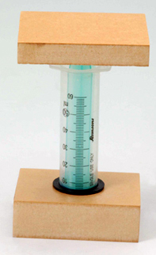

Analysis:
- Describe the effect that pressure has on the volume of the gas at a constant temperature. Explain this effect, Boyle’s Law, using the KMT.
- Why must this activity be conducted when the room temperature is constant?
- Would your results differ if you used a different gas in the syringe? Explain using the KMT.
- (a) Plot a graph of volume, V, against pressure, P (number of books).
- Plot a graph of 1/V against P.
- Use your graphs to develop a mathematical equation relating volume and pressure.
- Use your graphs to predict the volume if the following number of books was placed on the syringe. (i) 10 books (ii) 3.5 books

