Chemical Kinetics
Part 1: Collision Theory

Collision Theory
– used to explain why reactions do or do not occur and why they happen at different rates.
– particles are in constant, random motion (like KMT, but KMT is just for gases).
– collision between molecules provide energy necessary to break and rearrange bonds.

There are 3 important requirements to have successful and effective collisions:
1) Frequency of collisions – How many times they collide
2) Activation Energy (E_{A}) – How hard they hit
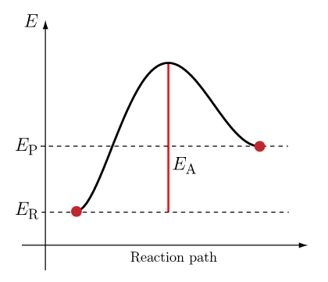

- The particles must collide and the collision energy must be at least equal or superior to the activation energy barrier
- An elastic collision occurs when particles collide and there is no reaction
- An inelastic collision occurs when reactant particles are transformed into product
- When looking at a potential energy diagram the higher the activation energy barrier (hill) the more difficult it is for the reaction to occur

3) Steric Factor – How they collide together

- The particles must be in the correct orientation in order to react.

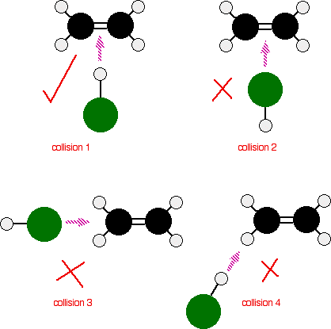

Simple and Complex reactions (Reaction Mechanism)
Simple reactions occur in one step:

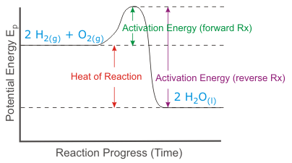
Most reactions do not occur in one step but a series of intermediate steps, each step is called an elementary reaction. Each elementary reaction forms a product which will be used up in the next step, we call them intermediates. They are unstable and do not last for a long period of time.

In the diagram seen below there are:
a) How many elementary steps?
b) How many intermediates are formed?
c) Which elementary reaction is slower (rate determining step)?
Reaction Mechanism
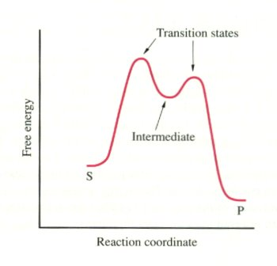

Activated Complex
R
Each step in the reaction has its own activation energy and produces its own activated complex. The energy level of activated complex determines the rate of each step.
The slowest step of a reaction is called the rate-determining step, this is the step where the energy level of activated complex is highest. An overall reaction cannot occur at a faster rate than its slowest step.

Example:
Nitrogen dioxide reacts with fluorine gas to produce nitrogen dioxyfluoride. The reaction is exothermic (ΔH = -284 kJ/mol). Assume the activation energy for the overall reaction is 240 kJ.
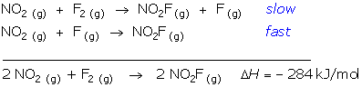
Sketch a potential energy diagram for this reaction mechanism and label the activation energy for each step and the activation energy for the overall reaction. Also label the rate determining step.

Plan a strategy.
There are two elementary processes, so the potential energy diagram will show two "humps". The reaction is exothermic, so the potential energy of the product is lower than that of the reactants. The higher of the two activation energy humps will be associated with the first elementary process because it is the rate determining step.

Communicate the answer.
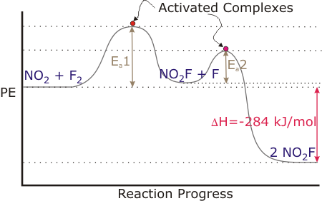
The activation of the overall reaction is the same as the activation energy of the first elementary process (step).

The 5 Factors that affect reaction rates
- Concentration
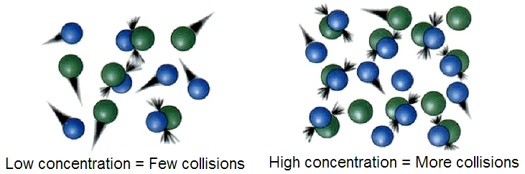

- Increasing concentration will increase the frequency and number of effective collisions which will increase the reaction rate

Similar to concentration, pressure affects the rate of reaction for gases. When you increase the pressure, the molecules have less space in which they can move. That greater concentration of molecules increases the number of collisions. When you decrease the pressure, molecules don't hit each other as often. The lower pressure decreases the rate of reaction.

NOTE: you can also increase pressure by decreasing the volume of a container

- Temperature (**only factor that effects the particle’s energy**)
- Increasing the temperature of the reaction will increase the kinetic energy of the particles
- This increases the frequency and number of effective collisions and the reaction rate.

- Surface Area
- Increasing the surface area will increase the number of particles that are available to react
- This increases the number of effective collisions and the reaction rate.

- Catalysts/Inhibitors (**only factor that will effect a potential energy diagram**)

POWER POINT

- Nature of the Reactants
There are 2 types of reactions:
Homogeneous reactions – involve reactants that are all in the same phase
Heterogeneous reactions – involve reactants that are in different phases
Homogeneous reactions are usually faster than heterogeneous reactions.

There are 2 primary factors related to reactant nature:
- Phase of the reactants
In general reaction rates can be classified from slowest to fastest as a function of phase of the reactants as follows:

SLOW SOLIDS→LIQUID→GAS→AQUEOUS IONS (FAST)
Solids will be slowest (only certain explosive exceptions like TNT or NI₃) because
the bonds are stronger between solid particles and they can only vibrate.

Aqueous substances will react fastest
DO NOT CONFUSE AQUEOUS AND LIQUID SUBSTANCES!
Aqueous substances which are ionically bonded form ions in solution, and liquids do not form ions since they have covalent bonds.
Ex. Neutralization: HCl(aq) + NaOH(aq) → H₂O(l) + NaCl(aq)
*instantaneous reaction*

B) The number and strength of the bonds in the reactants to be broken
Monatomic vs Polyatomic particles
Monatomic will be faster because the steric factor (orientation of the particle)
will not be important and there are no bonds to break. For larger polyatomic molecules, they must be in the correct orientation to hit the reactive site and there are multiple bonds to break. In general, less complex = faster

Ionic vs, Covalent Bonds
Ionic is faster because the bonds, where there is a transfer of electrons, are
easier to break. In a covalent bond the atoms share electrons which reinforces
the bond.

Ionic = metal + non-metal
Covalent = non-metal + non-metal or non-metal + metalloid

Also, when the reactant molecules have high total bond strength due
to high enthalpy bonds like double or triple bonds the reaction is slower than for
reactants with weak intramolecular bonds.
Combustion rates increase when…

-Area of fuel increases
-concentration of oxygen increases
-temperature increases
-with the presence of a catalyst (Ash)
-nature of the fuel

A shorter chain fuel ( ex. Propane C₃H₈) is more volatile and will vaporize more quickly than a longer chain fuel (ex. Wax C₂₅H₅₂). Fuels will only burn once they have vaporized. For a candle the solid wax must first melt and then vaporize so the candle can continue to burn.

Potential Energy Diagrams

ENDOTHERMIC

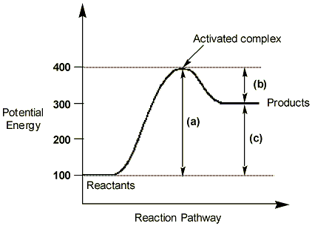
(kJ)

a) activation energy (E_{A}) of the forward reaction
b) activation energy (E_{A}) of the reverse reaction
c) ∆H - change in enthalpy

NOTE: when ∆H is positive (endothermic) the reaction is not favoured thermodynamically because the products end up with an increased amount of stored energy (enthalpy) than the reactants.

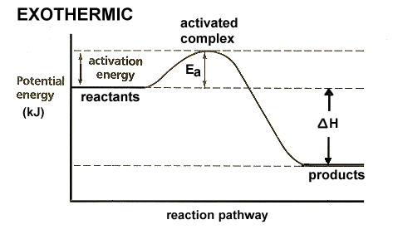
The activation energy indicates how easy it is for the reaction to occur a reaction with a small activation energy barrier will not require much energy and can happen spontaneously. A high activation energy will require a lot of energy and so it is more difficult for this reaction to occur.

The addition of a catalyst or inhibitor is the only factor that will effect a potential energy diagram.
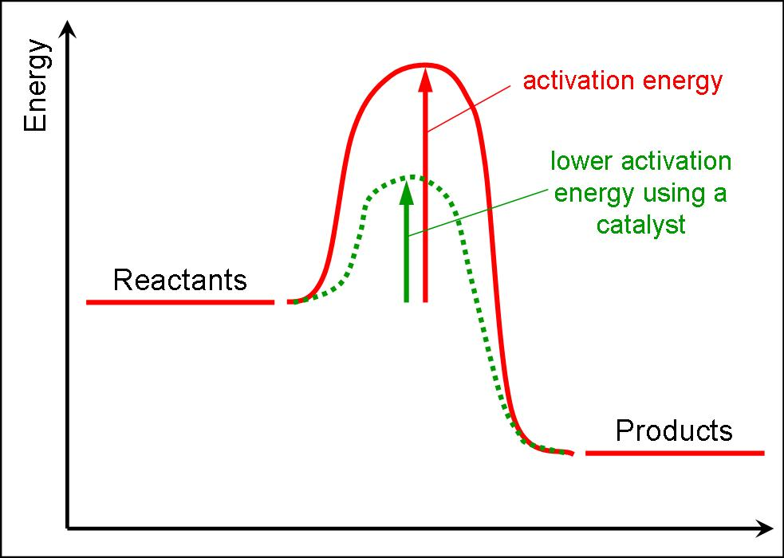

Draw the diagram for the addition of an inhibitor

Kinetic Energy (Maxwell-Boltzmann) Diagrams

All 5 factors that affect reaction rates will have an effect on the kinetic energy diagram.
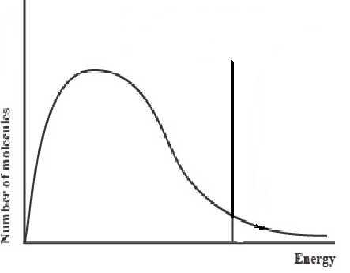
Molecules that do not have enough energy to surpass barrier
Molecules that have surpassed the barrier to become products

Addition of a catalyst
- Activation energy barrier shifts left
- Catalyst decreases the energy required for activation (more happy faces)

Addition of an inhibitor

Inhibitor will shift barrier to right (more sad particles)

Increase of Temperature

Decrease of Temperature

Increased concentration or surface area

Part 2 - Measuring Rates of Reaction

The Rate Law (Rate Equation)
-expresses the rate as a function of concentration of reactants, and temperature
-law is based on experimental facts and for our purposes we will only consider reactions where the reaction rate only depends on initial reactant concentrations at a fixed temperature.
For a general reaction:
xA + yB C + D
The rate law defines how the rate is affected by the concentration of each reactant.
The rate law is:
Rate = k [ A ]^{x}[ B ]^{y}

- [ ] represents concentration of each reacting species

- x and y are the reaction orders, they show the degree to which each reactant will affect the rate

- k is the specific rate constant that relates concentration of reactants to the reaction rate

Note:
Typically the components of the rate law must be found experimentally and cannot be determined by only using the stoichiometric ratios. For our purposes, we will only consider elementary (one-step) reactions in order to use those stoichiometric ratios.
Why is it useful?
Once we know the rate law we can use it to predict the rate for any initial reactant conditions.
Writing Rate Laws
Ex. 1: N₂(g) + 3H₂(g) → 2NH₃(g)

Ex. 2: CaCO₃(s) + 2HCl(g) → CaCl₂(aq) + CO₂(g) + H₂O(g)

Ex. 3 – Pg. 257 A

Ex. 4 – Pg 257 B

Ex. 5 – Pg. 258 C

Reaction Rate: Is a measure of how fast reactants are used up in reactions and products formed, in a certain period of time.
}

Units:
Mass (g) → g/s
Number of particles (mol) → mol/s
These are some possible units that vary over time.
Concentration (mol/L) → mol
L∙s
Volume (mL) → mL/s

We can determine the rate by calculating the ratio of the change in the amount of substance in a certain amount of time.

Reaction: A→ B

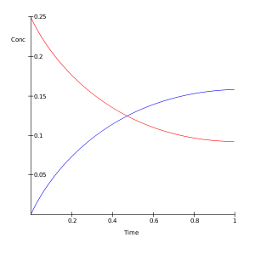
[ A ]
[ B ]

Note: The reaction rate is greater at the beginning of the
change, since at this point there are more particles of reactants
than at the end, making there be a greater opportunity for
effective collisions.

Qualitatively we know how quickly certain reactions will proceed

Ex. 1) Slow reaction – aging, copper roofs changing colour to green

2) Fast – magnesium strip burning, HCl and NaOH neutralization, formation of
precipitates

3) Explosive – TNT, NI₃ explosion

Quantitatively we can determine the reaction rate by measuring the ratio of the change in the amount (mol or g) of a substance in a certain amount of time (minutes or seconds).

Reaction: A→ B

Rate consumption: Rate = - ∆A ←Note: This top value must be
∆t negative, so that the rate is positive

Rate production: Rate = ∆B
∆t

Example 1: In the presence of water, 15.6 g of sodium peroxide, Na₂O_{2(s)}, forms sodium hydroxide, NaOH_{(aq)}, and releases oxygen gas, O_{2(g)}.
The reaction is represented by the following equation :
2 Na₂O_{2(s)} + 2 H₂O _{(l)} → 4 NaOH_{(aq)} + O_{2(g)}
Knowing that the reaction lasts 10 seconds, what is the average reaction rate of the sodium peroxide in moles per second?

Example 2: Given the situation described in example 1, what is the rate of formation of NaOH?

Example 3: Nitrogen gas, N₂, reacts with hydrogen gas, H₂, to produce ammonia, NH₃, according to the following equation :
N_{2(g)} + 3 H_{2(g)} → 2 NH_{3(g)}

At the beginning of the reaction, there are 2.0 mol of nitrogen gas and 6.0 mol of hydrogen gas. After 5 minutes, the system contains only 0.5 mol of nitrogen gas.
What is the average rate of formation of ammonia in mol/s?

Example 4: Many people keep a 3% solution of hydrogen peroxide (H₂O₂) in their medicine cabinets. One liter of hydrogen peroxide decomposes to oxygen gas and water as suggested below:
2 H₂O_{2(aq)} → 2 H₂O_{(l)} + O_{2(g)}
A simple method of showing the rate of this decomposition reaction would be to allow the oxygen gas to escape and to mass the accumulated oxygen gas.
Time, s | Accumulated mol of O_{2(g)} | [H₂O₂], mol/L remaining
0 | 0 | 0.882
60 | 0.0925
120 | 0.158
180 | 0.212
240 | 0.255
300 | 0.292

Based on the information given in the table, what is the average rate of decomposition of hydrogen peroxide solution from 60 s to 300 s in mol/L H₂O_{2(aq)} consumed per second?

Example 5: Examine the following hypothetical chemical reaction.
2 A_{(g)} + B_{(g)} → A₂B_{(g)}
The graph below shows the formation of the product A₂B over time, at a constant temperature and pressure.
a) Determine the average rate of the reaction for reactant A between 5 and 25 seconds in mol/L•s.

b) Determine the instantaneous formation rate at 5 s for product A₂B_{(g)}.

Example 6: The decomposition of nitrogen dioxide gas, NO₂, is shown in the following equation:
2 NO_{2(g)} → 2 NO_{(g)} + O_{2(g)}
The data table below indicates the concentration of oxygen gas as the reaction proceeds.
Time (minutes) | Concentration of O₂ (mol/L) | Concentration of NO (mol/L)
0 | 0 | 0
1 | 0.0160
2 | 0.0240
3 | 0.0288
4 | 0.0320
a) Calculate the average rate of formation of oxygen gas (O₂) between 1 and 4 minutes in .

b) Calculate the average rate of decomposition of nitrogen dioxide (NO₂) between 1 and 4 minutes in .

c) Complete the table for the formation of nitrogen oxide.

