Equilibrium

**What is equilibrium?**

Equilibrium occurs when 2 opposing processes (forward and reverse reactions) occur at the same rate.

What types of equilibrium exist?

1) *Phase equilibrium*: Occurs when a substance exists in more than one phase within a system as a result of a physical change.

Example: In an alcohol thermometer the alcohol will exist in liquid and gas phases, the liquid will vaporize until it reaches its maximum partial pressure. This is when equilibrium is achieved because the rate of evaporation of the molecules will be equal to the rate of condensation.

2) *Solubility equilibrium:* Occurs in a saturated solution where you can see excess solute at the bottom of the solution. Although it appears like nothing is happening the molecules of solute will actually continue to dissolve into the solution at the same time as they reform solid crystals. This is when equilibrium is achieved because the rate of dissolution is equal to the rate of precipitation.

3) *Chemical equilibrium:* Occurs during a chemical change where the forward and reverse reactions occur at the same rate.

**Conditions for Equilibrium:**

*Reversible:* In order for the reaction to reach equilibrium there needs to be 2 opposing processes occurring at the same rate which are the forward and reverse reactions.

*Closed System:* In order for a system to reach equilibrium the products of the forward or reverse reactions cannot be allowed to escape to the surrounding environment. This can occur in a sealed container or a system where none of the particles can escape to the outside environment.

For example, a can of pop will reach equilibrium between the liquid and the carbon dioxide as long as it is closed. At equilibrium the dissolution rate of the CO2 gas is equal to the rate that the CO2 will be released from the water.

In systems like saturated solutions the particles involved in the equilibrium cannot escape even though the system is open so equilibrium can be achieved.

*Macroscopic Properties are constant:* At equilibrium there are no visible (macro) changes of the properties that are occurring. Some of these properties include colour, volume, pH, temperature, pressure and excess solute.

*Microscopic Properties:* The concentration of the reactants and products are constant and the rates of the forward and reverse reactions are equal. At the molecular level, the changes that occur in the particles in one direction are balanced by changes in the other direction.

**Identifying Equilibrium on a Graph**

Since the concentrations of the reactants and products are constant at equilibrium we can easily identify when equilibrium has been achieved on a graph. At equilibrium, the rate of change of the curves for the reactant and product concentrations becomes zero (horizontal lines). `

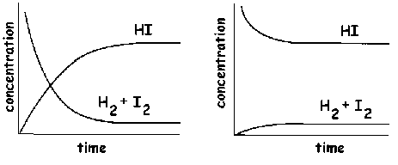

**Equilibrium Constant (Kc)**

For the equilibrium reaction,

A+B↔AB

Rate forward = kfwd [ A ] [ B ]

Rate reverse = krev [ AB ]

When equilibrium is reached, Rate forward = Rate reverse

kfwd [ A ] [ B ] = krev [ AB ]

kfwd = _ [ AB ]_

krev [ A ] [ B ]

The ratio of the constants for the forward and reverse reactions is simplified with Kc,

Kc = _ [ AB ]_

[ A ] [ B ]

The equilibrium constant will also take into account the molar coefficients as shown below,

aA + bB ↔ cC + dD

Kc = [ C ]c [ D ]d

[ A ]a [ B ]b

[ A ] [ B ] = Reactant concentrations at equilibrium

[ C ] [ D ] =Product concentrations at equilibrium

a, b = stoichiometric coefficients of the reactants

c, d = stoichiometric coefficients of the products

**RULE: Equilibrium constants do not include solids or liquids because their concentrations do not vary.

Examples:

1.

http://www.chemguide.co.uk/physical/equilibria/padding.gifhttp://www.chemguide.co.uk/physical/equilibria/so2so3eq.gif

Kc expression:

http://www.chemguide.co.uk/physical/equilibria/kccontact.gif

2.

http://www.chemguide.co.uk/physical/equilibria/padding.gifhttp://www.chemguide.co.uk/physical/equilibria/habereq2.gif

Kc expression is:

http://www.chemguide.co.uk/physical/equilibria/kchaber.gif

3.

http://www.chemguide.co.uk/physical/equilibria/padding.gifhttp://www.chemguide.co.uk/physical/equilibria/cuageq.gif

Both the copper on the left-hand side and the silver on the right are solids. Both are left out of the equilibrium constant expression.

http://www.chemguide.co.uk/physical/equilibria/kccuag.gif

4.

http://www.chemguide.co.uk/physical/equilibria/padding.gifhttp://www.chemguide.co.uk/physical/equilibria/caco3eq.gif

The only thing in this equilibrium which isn't a solid is the carbon dioxide. That is all that is left in the equilibrium constant expression.

http://www.chemguide.co.uk/physical/equilibria/kccaco3.gif

**The significance of the K value**

-used to indicate the position of the equilibrium

-dependent on temperature

The Keq shows whether the products (P) or reactants (R) are favoured at equilibrium.

Keq = [ P ]

[ R ]

So at equilibrium if [ P ] is large,

Keq = [ P ] The Keq > 1 indicates that the equilibrium system favours the forward

[ R ] reaction which causes there to be more product present at equilibrium.

When [ R ] is large,

Keq = [ P ] The Keq < 1 indicates that the equilibrium system favours the reverse

[ R ] reaction which causes there to be more reactant present at equilibrium.

When Keq = 1 then neither the product nor reactant are favoured

Keq ≠ 0

In general reactions where,

* Keq is > 1010, the reaction is considered to be complete.
* Keq is < 10-10, the reaction will not occur.

LeChatelier’s Principle

Henri Louis LeChatelier discovered that if you apply a change in conditions (stress) to a chemical system at equilibrium, the reaction will return to a new equilibrium by shifting in order to counteract the stress.

You can stress a chemical system by changing the conditions:

1) concentration of reactants or products

2) pressure

3) temperature

When a stress on the system causes the system to produce more product, we say that the system favours the forward reaction or that it has shifted to the right.

**R→P**

When the system shifts to the right the product concentration will increase.

When a stress on the system causes the system to produce more reactant, we say that the system favours the reverse reaction or that it has shifted to the left.

**R←P**

When the system shifts to the left the reactant concentrations will increase.

**The Effect of Concentration**

When the concentration of a reactant is increased this will increase the number of successful collisions to form the product and therefore the concentration of the product will increase. This will favour the forward reaction (shifts right).

When the concentration of a reactant is decreased this will decrease the number of successful collisions to form the product. As a result, the system will counteract this stress by favouring the reverse reaction (shift left) in order to increase the reactant concentration.

When product concentrations are increased this will increase the number of successful collisions for the reverse reaction. This will cause the system to favour the reverse reaction (shift left) and increase the concentration of the reactants.

When the product concentrations are decreased this will decrease the number of successful collisions for the reverse reaction. As a result, the system will counteract this stress by favouring the forward reaction (shift right) in order to increase the product concentration.

**Example 1:** Consider the reaction Fe3+(aq) + SCN-(aq) → FeSCN-(aq)

Tan Reddish-Brown

A) ↑ [ Fe3+]or [SCN-] - favours forward reaction (encourages formation of product)

- to relieve stress, shifts right

- ↑ in [FeSCN-]

B) ↓ [ Fe3+]or [SCN-] - favours reverse reaction (discourages formation of product)

- to relieve stress, shifts left to replace reactant

- ↓ in [FeSCN-]

C) ↑ [FeSCN-] - favours reverse reaction (encourages the formation of reactant)

- to relieve stress, shifts left

- ↑ [ Fe3+]or [SCN-]

D) ↓ [FeSCN-] - favours forward reaction (encourages the formation of product)

- to relieve stress, shifts right to replace product

- ↓ [ Fe3+]or [SCN-]

Another way to approach these problems with concentration is using the equil. constant:

**Example 2:** Consider the Haber reaction N2(g) + 3H2(g) →2 NH3(g)

Write the equilibrium expressions: Kc = _[ NH3 ]2_ or Kp = __ P NH32__

[ N2 ] [ H2 ] PN2 ∙ PH23

If we increase the concentration of N2, the K value would decrease, what would we need to do to in order to return the K value to it’s original value?

If we ↓ [ N2 ], what effect will this have on the equilibrium constant (K value)? How will the system react?

If we ↑ [ NH3 ], what effect will this have on the K value? How will the system react?

If we ↓ [ NH3 ], what effect will this have on the K value? How will the system react?

**The Effect of Changes of Energy (ex . Heat)**

In general, if energy is added to a reaction the system will counteract this stress by shifting in the direction where energy will be absorbed. Contrary to this, if energy is removed from a reaction the system will counteract this stress by shifting in the direction where more energy will be produced in order to replace the lost energy. The direction of the shift is dependent on whether the reaction is exothermic or endothermic.

For the equilibrium constant (K), since it is temperature dependent, the addition or removal of heat from the system will cause the equilibrium constant to change.

**Example 1** Consider the Haber reaction N2(g) + 3H2(g) ↔ 2NH3(g) + Heat

**Forward Reaction – Exothermic** **Reverse Reaction – Endothermic**

N2(g) + 3H2(g) →2NH3(g) + Heat 2NH3(g) + Heat → N2(g) + 3H2(g)

1. As energy is added to the system, the reaction will favour the direction that will absorb heat (endothermic reaction). Therefore, in this case it will favour the reverse reaction (shifts left). 2NH3(g) + Heat → N2(g) + 3H2(g)
2. As energy is removed from the system, the reaction will favour the direction that will release heat (exothermic reaction). Therefore, in this case it will favour the forward reaction (shifts right). N2(g) + 3H2(g) →2NH3(g) + Heat

**Example 2** Consider this system at equilibrium:

2 CO2(g) + 570 kJ ↔ 2 CO(g) + O2(g)

The equilibrium constant is K = 4.46 × 10-23 at 727°C.

If the system is modified by increasing the temperature to 1000°C, what will happen to the equilibrium constant at this new temperature?

**The Effect of Pressure**

There are 3 ways to change the pressure in a reacting system:

1. Increase or decrease of the partial pressure of reactant or product particles
2. A change in volume of the reaction vessel
3. Addition of an inert gas (a gas not involved in the reaction)

For situation A, this has the same effect as changing the concentration of the reactant or product particles.

For situation B, a change in the volume of the reaction vessel will only affect systems with an unequal number of moles for reactants vs. products. Remember: Boyle’s Law, inverse relationship between pressure and volume.

**Example 1** Consider the Haber reaction N2(g) + 3H2(g) ↔ 2NH3(g)

 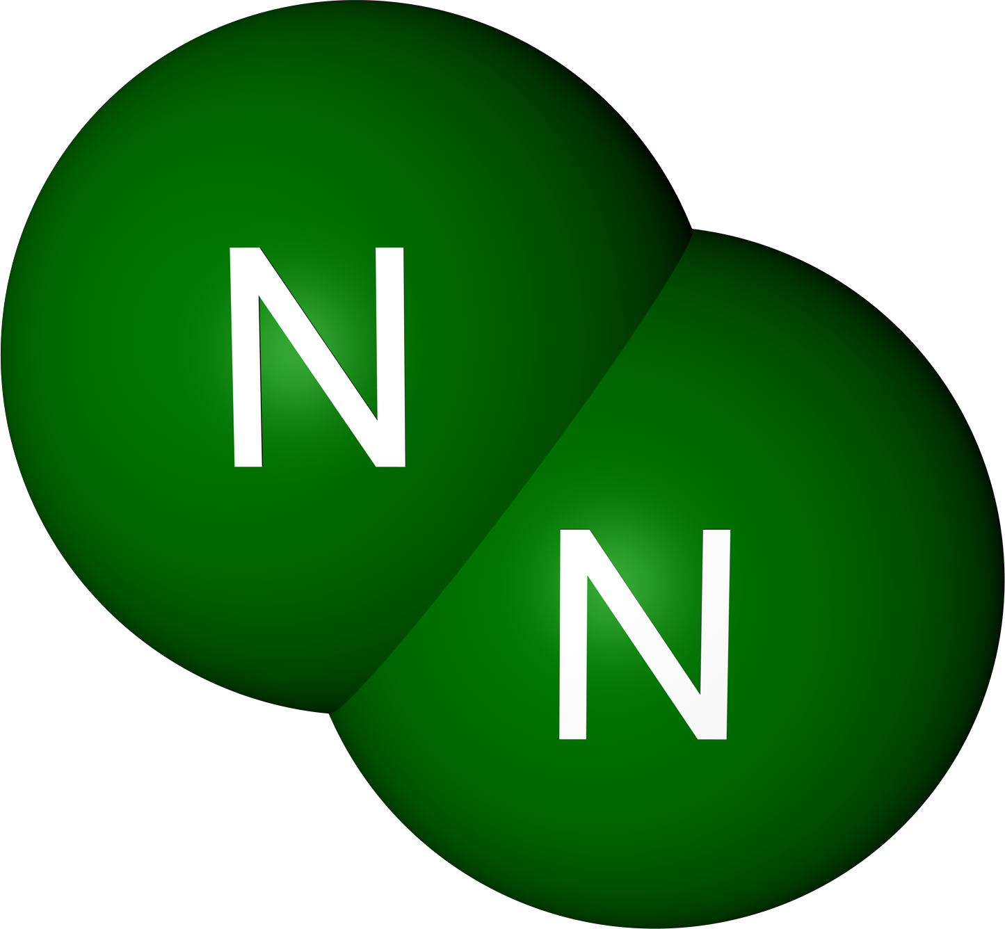 [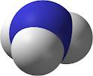](http://www.google.ca/imgres?imgurl=http://www.chemicals-technology.com/projects/pequivenammonia/images/2-ammonia-molecule.jpg&imgrefurl=http://www.chemicals-technology.com/projects/pequivenammonia/pequivenammonia2.html&usg=__8lxOeIIBOpXx1VRK2qg9vJOAxTc=&h=330&w=400&sz=33&hl=en&start=6&zoom=1&tbnid=sKLY8a8iesG8sM:&tbnh=102&tbnw=124&ei=-fppT8HDO9LqgQeNrYyeCQ&prev=/search?q=ammonia+molecule&um=1&hl=en&safe=active&sa=N&rls=com.microsoft:en-us&tbm=isch&um=1&itbs=1)

[](http://www.google.ca/imgres?imgurl=http://www.chemicals-technology.com/projects/pequivenammonia/images/2-ammonia-molecule.jpg&imgrefurl=http://www.chemicals-technology.com/projects/pequivenammonia/pequivenammonia2.html&usg=__8lxOeIIBOpXx1VRK2qg9vJOAxTc=&h=330&w=400&sz=33&hl=en&start=6&zoom=1&tbnid=sKLY8a8iesG8sM:&tbnh=102&tbnw=124&ei=-fppT8HDO9LqgQeNrYyeCQ&prev=/search?q=ammonia+molecule&um=1&hl=en&safe=active&sa=N&rls=com.microsoft:en-us&tbm=isch&um=1&itbs=1)  

6 particles

  [](http://www.google.ca/imgres?imgurl=http://www.chemicals-technology.com/projects/pequivenammonia/images/2-ammonia-molecule.jpg&imgrefurl=http://www.chemicals-technology.com/projects/pequivenammonia/pequivenammonia2.html&usg=__8lxOeIIBOpXx1VRK2qg9vJOAxTc=&h=330&w=400&sz=33&hl=en&start=6&zoom=1&tbnid=sKLY8a8iesG8sM:&tbnh=102&tbnw=124&ei=-fppT8HDO9LqgQeNrYyeCQ&prev=/search?q=ammonia+molecule&um=1&hl=en&safe=active&sa=N&rls=com.microsoft:en-us&tbm=isch&um=1&itbs=1)

[](http://www.google.ca/imgres?imgurl=http://www.chemicals-technology.com/projects/pequivenammonia/images/2-ammonia-molecule.jpg&imgrefurl=http://www.chemicals-technology.com/projects/pequivenammonia/pequivenammonia2.html&usg=__8lxOeIIBOpXx1VRK2qg9vJOAxTc=&h=330&w=400&sz=33&hl=en&start=6&zoom=1&tbnid=sKLY8a8iesG8sM:&tbnh=102&tbnw=124&ei=-fppT8HDO9LqgQeNrYyeCQ&prev=/search?q=ammonia+molecule&um=1&hl=en&safe=active&sa=N&rls=com.microsoft:en-us&tbm=isch&um=1&itbs=1)

🡫 Volume 🡩 Volume

  

 

  

4 particles

8 particles

[](http://www.google.ca/imgres?imgurl=http://www.chemicals-technology.com/projects/pequivenammonia/images/2-ammonia-molecule.jpg&imgrefurl=http://www.chemicals-technology.com/projects/pequivenammonia/pequivenammonia2.html&usg=__8lxOeIIBOpXx1VRK2qg9vJOAxTc=&h=330&w=400&sz=33&hl=en&start=6&zoom=1&tbnid=sKLY8a8iesG8sM:&tbnh=102&tbnw=124&ei=-fppT8HDO9LqgQeNrYyeCQ&prev=/search?q=ammonia+molecule&um=1&hl=en&safe=active&sa=N&rls=com.microsoft:en-us&tbm=isch&um=1&itbs=1)

-Originally we have 6 particles, as the pressure increases due to the decrease in volume the system will shift to the side with the least number of moles in order to compensate for the increase in pressure.

-As the pressure drops due to the increase in volume the system will shift to the side with more moles order to compensate for the loss in pressure.

**Example 2** Consider reaction Br2(g) + Cl2(g) ↔ 2BrCl(g)

For this reaction changing the volume of the container will have no effect on the equilibrium because there are an equal number of moles of reactants and products.

For Situation C the addition of an inert gas increases the total pressure within the container but has no effect on the equilibrium. This can be explained by the fact that the number of collisions occurring within the reaction vessel will increase but it will not increase the number of successful collisions.

**Addition of a Catalyst or Inhibitor**

A catalyst will decrease the activation energy barrier and an inhibitor will increase the activation energy barrier. This will affect the forward and reverse reactions in the same way. Therefore, a catalyst or an inhibitor have no impact on the equilibrium ie. they will not cause any shifting to occur.

For a catalyst the equilibrium will be reached more quickly and a system will take a longer time to reach equilibrium if an inhibitor is added.